AURA Info
Venv>>aura-s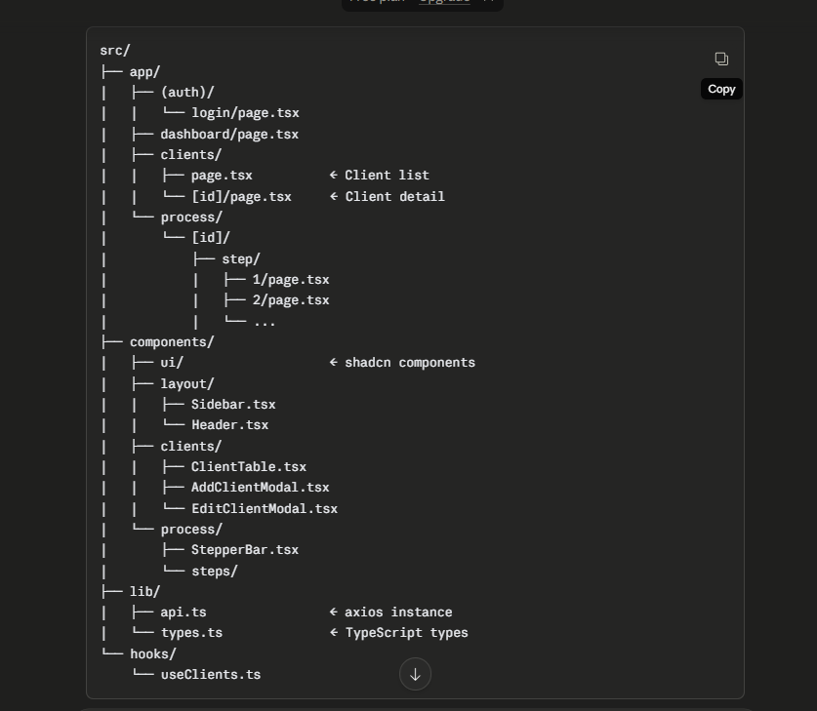

20 May 2026 Completed below
✅ Project setup done (Next.js + FastAPI + MongoDB)
✅ Client Management — List, Add, Edit, Delete, Detail Page (UI + APIs)
✅ Process Discovery — Step 1, 2, 3 (UI + APIs)
✅ Step 4 — File Upload UI + Activity Table UI done
✅ Backend running on localhost:8000

Pending (Sarthak):
⏳ Step 5, 6, 7 UI + Dashboard + Login

Pending (Pratyush):
⏳ Azure Blob Storage + AI Agents (Step 4, 5, 6, 7)

When I need Pratyush:
→ 2–3 Jun — Step 4 File Upload endpoint + AI Activity Extraction agent should be ready (frontend polling is done, waiting on backend AI)
→ 5–6 Jun — GSDA AI Hint Agent
→ 9 Jun — Archetype Generation Agent
→ 14 Jun — AI Summary + PDF Export

On track as per schedule.

Thanks